Cascaded Style Sheet

Ex1:-

<!DOCTYPE html>

<html lang="en">

<head>

    <style>

        h1{

            background-color:red;

            color:white;

            padding:5px;

        }

        p{

            color:blue;

        }

    </style>

</head>

<body>

    <h1>Write your First Css Example</h1>

    <p>This is paragraph</p>

</body>

</html>

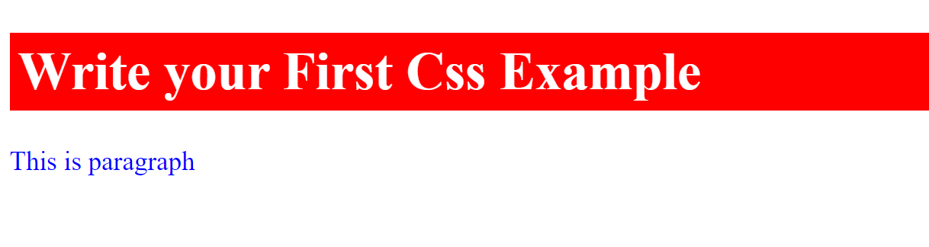

Syntax:-

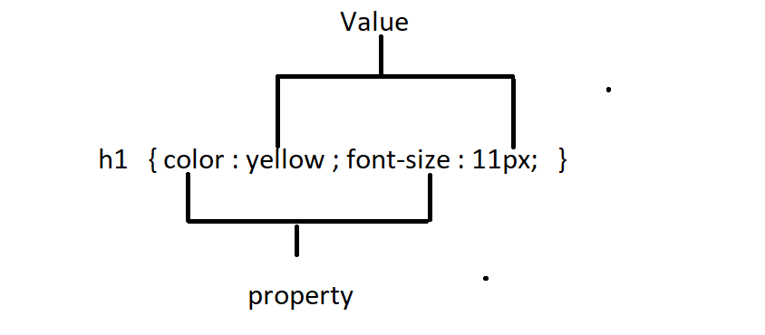

Selectors In Css

1)Html Selector

2)Id Selector

3)Class Selector

4)Universal Selector

5)Group Selector

1)Html Selector:-

<!DOCTYPE html>

<html lang="en">

<head>

    <style>

        p{

            text-align: center;

            color: #ff0000;

        }

    </style>

</head>

<body>

    <p>Hello Css!</p>

</body>

</html>



2)Id Selector:-

*its unique

*its always start with hash symbole(#)

<!DOCTYPE html>

<html lang="en">

<head>

    <style>

        #p1{

            text-align: center;

            color:red;

        }

    </style>

</head>

<body>

    <p id="p1">Hello VF pages</p>

    <p>Hello LWC Components</p>

    <p></p>

</body>

</html>



3)Class Selector:-

*its create with period symbol(.)

*its not be unique

<!DOCTYPE html>

<html lang="en">

<head>

   <style>

       .c1{

           text-align: center;

           color:blue;

           font-size: 10px;

       }

   </style>

</head>

<body>

    <h1 class="c1">This is heading with blue color text and align is center</h1>

    <p class="c1">This is paragraph with blue color text and align is center</p>

    <div class="c1">This is div with blue color text and align is center</div>

</body>

</html>

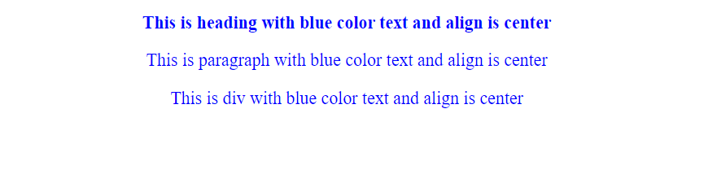

Ex2:-class also allows multiple classes in single class attribute

<!DOCTYPE html>

<html lang="en">

<head>

   <style>

       .c1{

           text-align: center;

           color:blue;

           font-size: 10px;

       }

       .c2{

           background-color:aqua;

       }

   </style>

</head>

<body>

    <h1 class="c1">This is heading with blue color text and align is center</h1>

    <p class="c1 c2">This is heading with blue color text and align is centerparagraph with blue color text and align is center</p>

    <div class="c1">This is div with blue color text and align is center</div>

</body>

</html>



4)Universal Selector:-

*it defines with an asterisk symbole(*)

<!DOCTYPE html>

<html lang="en">

<head>

    <style>

        *{

            font-family:Arial,Verdana, Geneva, Tahoma, sans-serif;

            color:cyan;

            font-style: italic;

            font-weight: bold;

        }

    </style>

</head>

<body>

    <h1>This is heading</h1>

    <p>This is p tag</p>

    <div>this is div tag</div>

</body>

</html>



5)Group Selector:-

<!DOCTYPE html>

<html lang="en">

<head>

    <style>

        h1,p,div,.c1,#myid{

            font-family:Arial,Verdana, Geneva, Tahoma, sans-serif;

            color:cyan;

            font-style: italic;

            font-weight: bold;

        }

    </style>

</head>

<body>

    <h1>This is heading</h1>

    <p>This is p tag</p>

    <div>this is div tag</div>

    <h2>This is heading-2</h2>

    <h3 class="c1">This is heading-3</h3>

    <h4 id="myid">This is heading-4</h4>

</body>

</html>

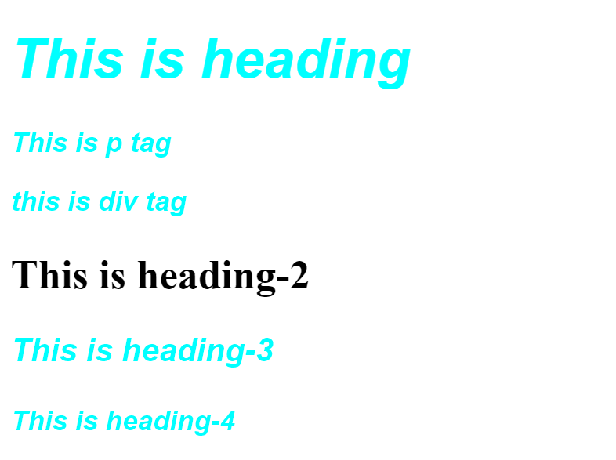

How to Add Css

1)Inline css

2)Internal css

3)External css

1)Inline css:-

Ex:-

<!-- inline css -->

<!DOCTYPE html>

<html>

<body>

    <p style="color:red">Hello Apex</p>

    <p style="color:green;margin-left: 20px;">Hello Aura</p>

    <p>Hello <span style="background:yellow;">LWC</span></p>

</body>

</html>

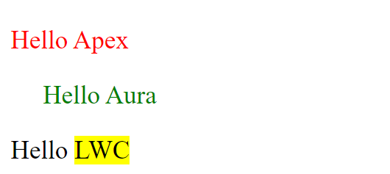

2)Internal Css:-

<!-- internal css -->

<!DOCTYPE html>

<html>

    <head>

        <style>

            p{

                color:red;

                font-weight:bold;

            }

            .myclass{

                color:green;

                background-color:chocolate;

                text-align:right;

            }

        </style>

    </head>

<body>

    <p>Hello Apex</p>

    <p>Hello Aura</p>

    <h1>Hello LWC</h1>

    <h1 class="myclass">Hello Clasic</h1>

    <h1 class="myclass">Hello Html</h1>

</body>

</html>

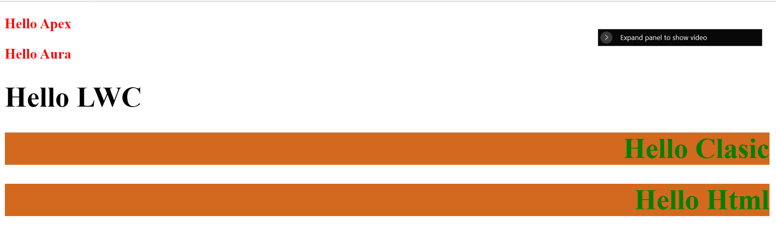

3)External CSS:-

a)Style.css

a{

    color:red;

    display:block;

}

b)prog1:-

<!DOCTYPE html>

<html lang="en">

<head>

    <link rel="stylesheet" href="style.css"></link>

</head>

<body>

   <a href="#">Home</a>

   <a href="#">About us</a>

   <a href="#">Contact us</a>

</body>

</html>

c)prog2:-

<!DOCTYPE html>

<html lang="en">

<head>

<link rel="stylesheet" href="style.css"></link>

</head>

<body>

   <a href="#">Home</a>

   <a href="#">About us</a>

   <a href="#">Contact us</a>

</body>

</html>



**CSS Background**

This property is used to define background effect on element

There are 5 types of background properties

1)background-color

2) background-image

3) background-repeat

4) background-attachment

5) background-position

1. background-color:-
2. <!DOCTYPE html>
3. <html lang="en">
4. <head>
5. <style>
6. h2,p{
7. background-color:red;
8. color:white;
9. }
10. </style>
11. </head>
12. <body>
13. <h2>I am in H2 tag</h2>
14. <p>I am in p tag</p>
15. </body>
16. </html>

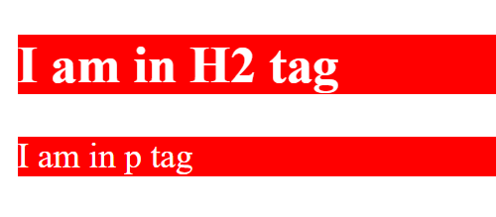

2)background-image:-

<!DOCTYPE html>

<html lang="en">

<head>

   <style>

       body{

           background-image:url('../img/2.jpg');

       }

   </style>

</head>

<body>

    <h1>This is heading</h1>

</body>

</html>



3)background-repeat:-

3.a)background-repeat:repeat-x;

<!DOCTYPE html>

<html lang="en">

<head>

   <style>

       body{

           background-image:url('../img/2.jpg');

           background-repeat:repeat-x;

       }

   </style>

</head>

<body>

    <h1>This is heading</h1>

</body>

</html>



3.b)background-repeat:repeat-y

<!DOCTYPE html>

<html lang="en">

<head>

   <style>

       body{

           background-image:url('../img/2.jpg');

          /* background-repeat:repeat-x;*/

           background-repeat:repeat-y;

       }

   </style>

</head>

<body>

    <h1>This is heading</h1>

</body>

</html>



4) background-attachment

<!DOCTYPE html>

<html lang="en">

<head>

   <style>

       body{

           background-image:url('../img/2.jpg');

          /* background-repeat:repeat-x;*/

           background-repeat:no-repeat;

           background-attachment: Fixed;

       }

   </style>

</head>

<body>

    <h1>This is heading</h1>

    <p>

        lorem ipsum dolor sit amet, consectetur adip

        lorem ipsum dolor sit amet, consectetur adip

        lorem ipsum dolor sit amet, consectetur adip

        lorem ipsum dolor sit amet, consectetur adip

        lorem ipsum dolor sit amet, consectetur adip

        lorem ipsum dolor sit amet, consectetur adip

        lorem ipsum dolor sit amet, consectetur adip

    </p>

</body>

</html>

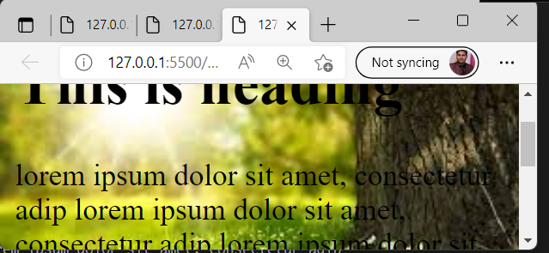

5)background-position:

<!DOCTYPE html>

<html lang="en">

<head>

   <style>

       body{

           background-image:url('../img/2.jpg');

          /* background-repeat:repeat-x;*/

           background-repeat:no-repeat;

           background-attachment: Fixed;

           background-position: center;

       }

   </style>

</head>

<body>

    <h1>This is heading</h1>

    <p>

        lorem ipsum dolor sit amet, consectetur adip

        lorem ipsum dolor sit amet, consectetur adip

        lorem ipsum dolor sit amet, consectetur adip

        lorem ipsum dolor sit amet, consectetur adip

        lorem ipsum dolor sit amet, consectetur adip

        lorem ipsum dolor sit amet, consectetur adip

        lorem ipsum dolor sit amet, consectetur adip

    </p>

</body>

</html>

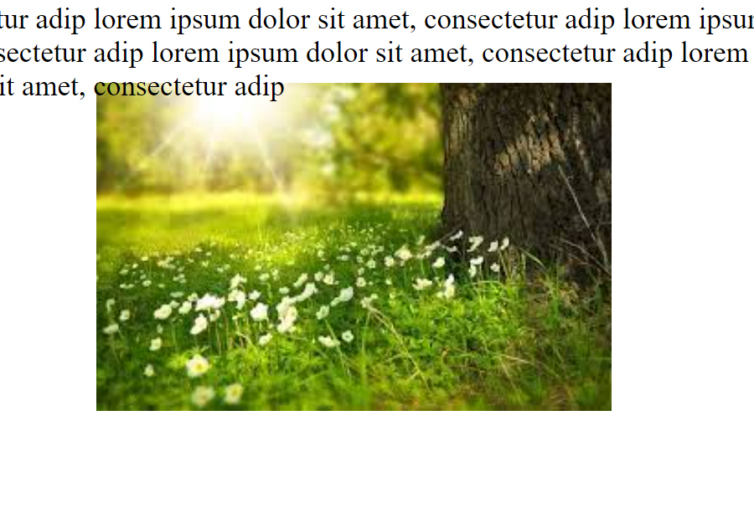

**CSS Border:-**

1)border-style

2)border-color

3)border-width

4)border-radius

There are some border style values:-

|  |  |
| --- | --- |
| Value | Description |
| None | Doesn,t defined any border |
| Dotted |  |
| Dashed |  |
| Solid |  |
| Double |  |
| Groove |  |
| Ridge |  |
| Inset | outset |

<!DOCTYPE html>

<html lang="en">

<head>

    <style>

    p.none{border-style:none;}

    p.dotted{border-style:dotted;}

    p.dashed{border-style:dashed;}

    p.solid{border-style:solid;}

    p.double{border-style:double;}

    p.groove{border-style:groove;}

    p.ridge{border-style:ridge;}

    p.inset{border-style:inset;}

    p.outset{border-style:ouset;}

    p.hidden{border-style:hidden;}

</style>

</head>

<body>

    <p class="none">none</p>

    <p class="dotted">dotted</p>

    <p class="dashed">dashed</p>

    <p class="solid">solid</p>

    <p class="double">double</p>

    <p class="groove">groove</p>

    <p class="ridge">ridge</p>

    <p class="inset">inset</p>

    <p class="outset">outset</p>

    <p class="hidden">hidden</p>

</body>

</html>

